Date: 19/05/2022

Lab Session No.: 12

**Aim:**

Develop an android application using SQLite to perform CRUD Operations

**Software’s /IDE Tools:**

Android Development Kit / Android Studio

**Application User interface design:**

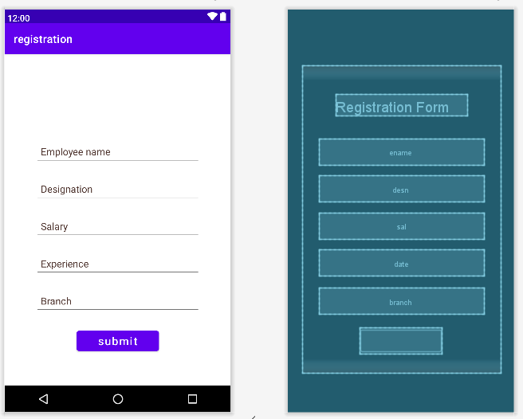

**Application Programming Interface:**

|  |  |  |  |
| --- | --- | --- | --- |
| **API / PACKAGES** | **CLASSES / INTERFACES** | **METHODS** | **DESCRIPTION** |
| import androidx.appcompat.app.AppCompatActivity; | AppCompatActivity | protected void onCreate(Bundle savedInstanceState) | onCreate(Bundle) is where you initialize your activity. When Activity is started and application is not loaded, then both onCreate() methods will be called. |
|  |  |
| import android.widget.EditText; | EditText | getText() | Determines the minimum type that getText() will return. If set, specifies that this TextView has a textual input method and should automatically capitalize what the user types. |

**Code/Implementation:**

*MainAcitivity.java*

**package** com.avinash.registration;  
**import** androidx.appcompat.app.AppCompatActivity;  
**import** android.os.Bundle;  
**import** android.view.View;  
**import** android.widget.Button;  
**import** android.widget.EditText;  
**import** android.widget.Toast;  
**public class** MainActivity **extends** AppCompatActivity {  
  
 EditText **name**,**desn**,**sal**,**date**,**brn**;  
 Button **subm**;  
 String **enm**,**dsn**,**sl**,**bn**;  
 **int xp**;  
 @Override  
 **protected void** onCreate(Bundle savedInstanceState) {  
 **super**.onCreate(savedInstanceState);  
 setContentView(R.layout.***activity_main***);  
 **name**=findViewById(R.id.***ename***);  
 **desn**=findViewById(R.id.***desn***);  
 **sal**=findViewById(R.id.***sal***);  
 **date**=findViewById(R.id.***date***);  
 **brn**=findViewById(R.id.***branch***);  
 **subm**=findViewById(R.id.***submit***);  
 **subm**.setOnClickListener(**new** View.OnClickListener() {  
 @Override  
 **public void** onClick(View view) {  
 **enm**=**name**.getText().toString();  
 **dsn**=**desn**.getText().toString();  
 **bn**=**brn**.getText().toString();  
 **sl**=**sal**.getText().toString();  
 **xp**=Integer.*parseInt*(**date**.getText().toString());  
 DBHelper dh=**new** DBHelper(MainActivity.**this**);  
 dh.registeruser(**enm**,**bn**,**dsn**,**xp**);  
 Toast.*makeText*(MainActivity.**this**, **"Registered**

Toast.***LENGTH_SHORT***).show();  
 }  
 });  
 }  
}

*activity_main.xml*

*<?***xml version="1.0" encoding="utf-8"***?>*<**LinearLayout xmlns:android="http://schemas.android.com/apk/res/android"  
 xmlns:app="http://schemas.android.com/apk/res-auto"  
 xmlns:tools="http://schemas.android.com/tools"  
 android:layout_width="wrap_content"  
 android:layout_height="wrap_content"  
 android:orientation="vertical"  
 android:layout_gravity="center"  
 android:padding="20dp"  
  
 tools:context=".MainActivity"**>  
 <**TextView  
 android:layout_width="wrap_content"  
 android:layout_height="wrap_content"  
 android:text="Registration Form"  
 android:layout_gravity="center"  
 android:textSize="30dp"  
 android:textColor="@color/white"  
 android:layout_margin="30dp"**/>  
  
 <**EditText  
  
 android:id="@+id/ename"  
 android:layout_width="300dp"  
 android:layout_height="wrap_content"  
 android:layout_margin="10dp"  
  
 android:hint="Employee name"  
 android:minHeight="48dp"  
 android:padding="10dp"  
 android:textColorHint="#4E342E"** />  
  
 <**EditText  
 android:id="@+id/desn"  
 android:layout_width="300dp"  
 android:layout_height="wrap_content"  
 android:layout_margin="10dp"  
  
 android:hint="Designation"  
 android:minHeight="48dp"  
 android:padding="10dp"  
 android:textColorHint="#4E342E"** />  
  
 <**EditText  
 android:id="@+id/sal"  
 android:layout_width="300dp"  
 android:layout_height="wrap_content"  
 android:layout_margin="10dp"  
  
 android:hint="Salary"  
 android:minHeight="48dp"  
 android:padding="10dp"  
 android:textColorHint="#4E342E"** />  
  
 <**EditText  
 android:id="@+id/date"  
 android:layout_width="300dp"  
 android:layout_height="wrap_content"  
 android:layout_margin="10dp"  
  
 android:hint="Experience"  
 android:inputType="text"  
 android:minHeight="48dp"  
 android:padding="10dp"  
 android:textColorHint="#4E342E"** />  
  
 <**EditText  
 android:id="@+id/branch"  
 android:layout_width="300dp"  
 android:layout_height="wrap_content"  
 android:layout_margin="10dp"  
  
 android:hint="Branch"  
 android:minHeight="48dp"  
 android:padding="10dp"  
 android:textColorHint="#4E342E"** />  
 <**Button  
 android:layout_width="150dp"  
 android:layout_height="wrap_content"  
 android:hint="submit"  
  
 android:textColorHint="#F8F9FB"  
 android:textSize="20dp"  
 android:id="@+id/submit"  
 android:layout_margin="15dp"  
 android:layout_gravity="center"** />  
  
</**LinearLayout**>

*DBHelper.java*

**package** com.avinash.registration;  
**import** android.content.ContentValues;  
**import** android.content.Context;  
**import** android.database.sqlite.SQLiteDatabase;  
**import** android.database.sqlite.SQLiteOpenHelper;  
**import** android.view.contentcapture.ContentCaptureCondition;  
**import** androidx.annotation.Nullable;  
**public class** DBHelper **extends** SQLiteOpenHelper {  
 **public static final** String ***DBNAME***=**"registration.db"**;  
 **private static final** String ***TABLE_NAME***=**"Register"**;  
 **private static final** String ***Empname***=**"Ename"**;  
 **private static final** String ***Branch***=**"Branch"**;  
 **private static final** String ***Exp***=**"Exp"**;  
 **private static final** String ***Design***=**"Desn"**;  
  
 **public** DBHelper(Context context) {  
 **super**(context, ***TABLE_NAME***, **null**, 1);  
 }  
  
 @Override  
 **public void** onCreate(SQLiteDatabase sqLiteDatabase) {  
 String query=**"CREATE TABLE "**+***TABLE_NAME***+**"("**+***Empname***+**" TEXT,"**+***Branch***+**"**

**TEXT,"**+***Design***+**" TEXT,"**+***Exp***+**" INTEGER)"**;  
 sqLiteDatabase.execSQL(query);  
  
 }  
 **public void** registeruser(String ename,String branch,String desgn,**int** exp){  
 SQLiteDatabase db=**this**.getWritableDatabase();  
 ContentValues c=**new** ContentValues();  
 c.put(**"Ename"**,ename);  
 c.put(**"Branch"**,branch);  
 c.put(**"Exp"**,exp);  
 c.put(**"Desn"**,desgn);  
 Long result=db.insert(***TABLE_NAME***,**null**,c);  
 }  
  
 @Override  
 **public void** onUpgrade(SQLiteDatabase sqLiteDatabase, **int** i, **int** i1) {  
 sqLiteDatabase.execSQL(**"DROP TABLE IF EXISTS "**+***TABLE_NAME***);  
 onCreate(sqLiteDatabase);  
  
 }  
}

**Output:**

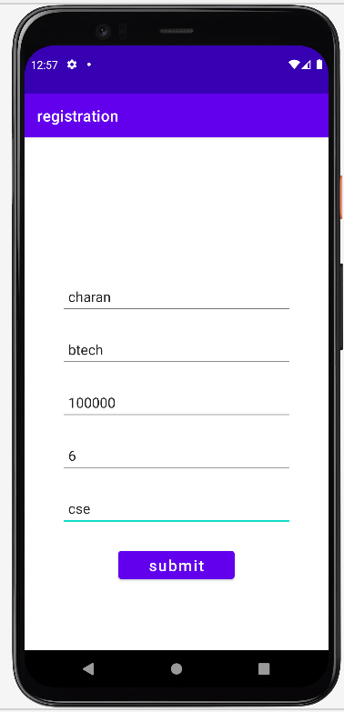  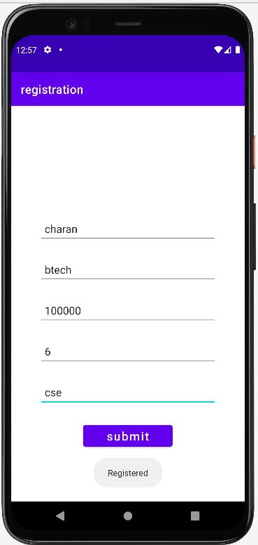

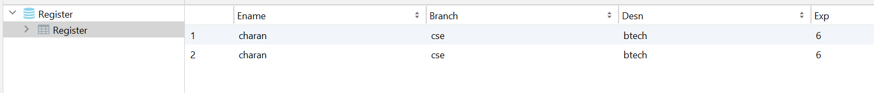

**Result:**

Demonstration of SQLite to perform CRUD Operations were done successfully.